// Assignment no-3(2)

// Name- Prerana Rajesh Gajare Class-SEIT RollNo-SI41

/\*PROBLEM STATEMENT:-

3. Write an Embedded C program to transfer elements from one location to another for following:

ii) Internal to external memory transfer

\*/

//Source Code:-

#include <xc.h>

#include <stdio.h>

#include <stdlib.h>

#include <pic18f4550.h>

void main()

{

int i;

int source1[]= {0x01, 0x02, 0x03, 0x04, 0x05};

int dest[]= {0x06, 0x07, 0x08, 0x09, 0xa};

int temp;

for(i=0;i<=4;i++)

{

temp=source1[i];

source1[i]=dest[i];

dest[i]=temp;

}

TRISD=0;

TRISB=0;

for(i=0;i<=4;i++)

{

PORTB=dest[i];

PORTD=source1[i];

/\* for(int n=0;n<1000;n++)

{

for(int j=0;j<500;j++)

{

}

}\*/

}

}

\*\*\*\*\*\*\*\*\*\*\*\*\*\*\*\*\*\*\*\*\*\*\*\*\*\*\*\*\*\*\*\*\*\*\*\*\*OUTPUT\*\*\*\*\*\*\*\*\*\*\*\*\*\*\*\*\*\*\*\*\*\*\*\*\*\*\*\*\*\*\*\*\*\*\*\*\*\*

1. I/O VIEW

PORT D

A]06

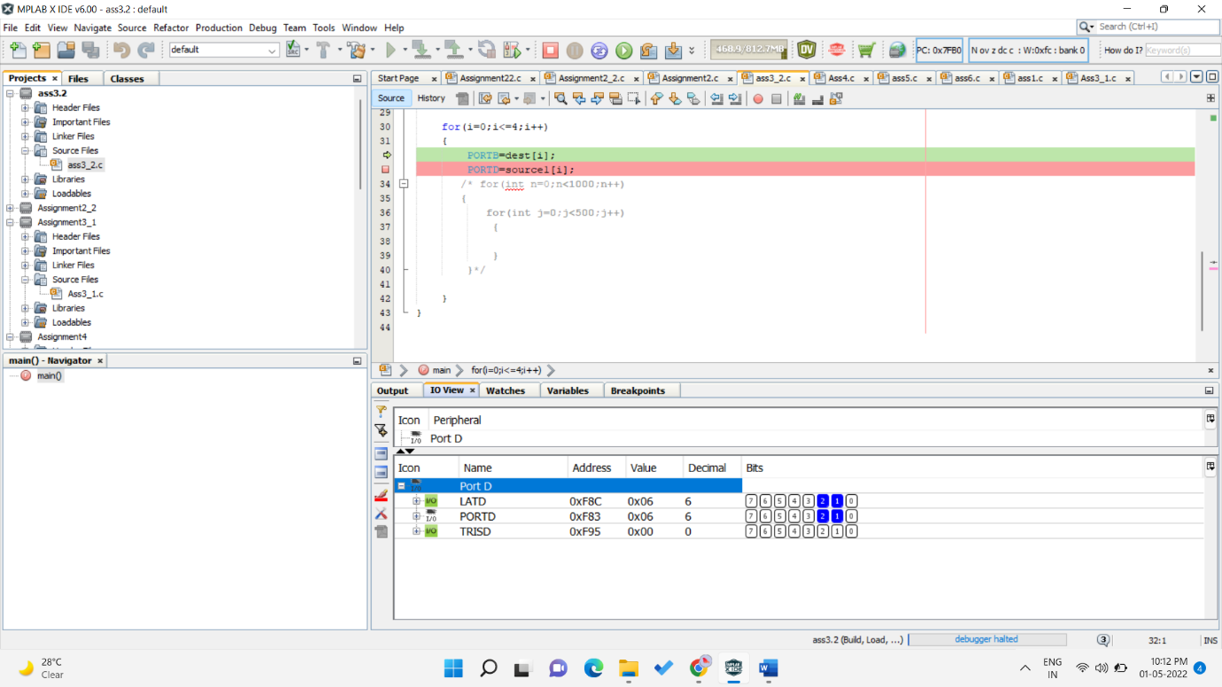

B]07

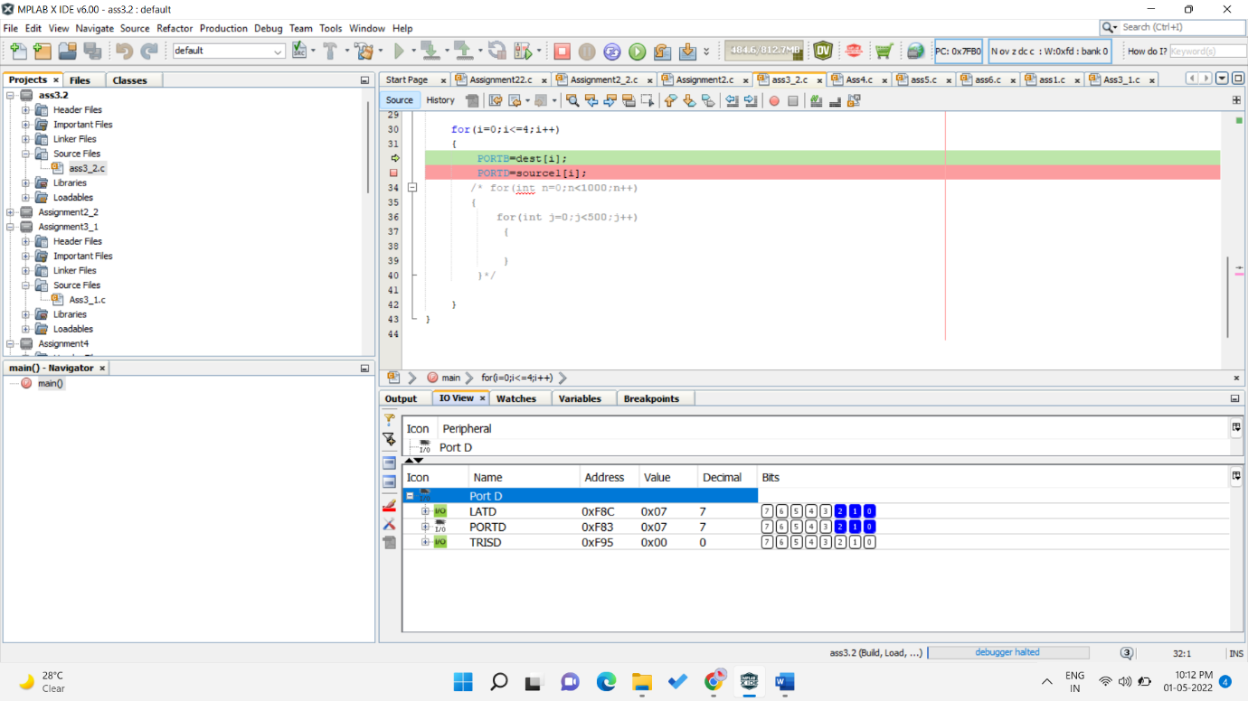

C]08

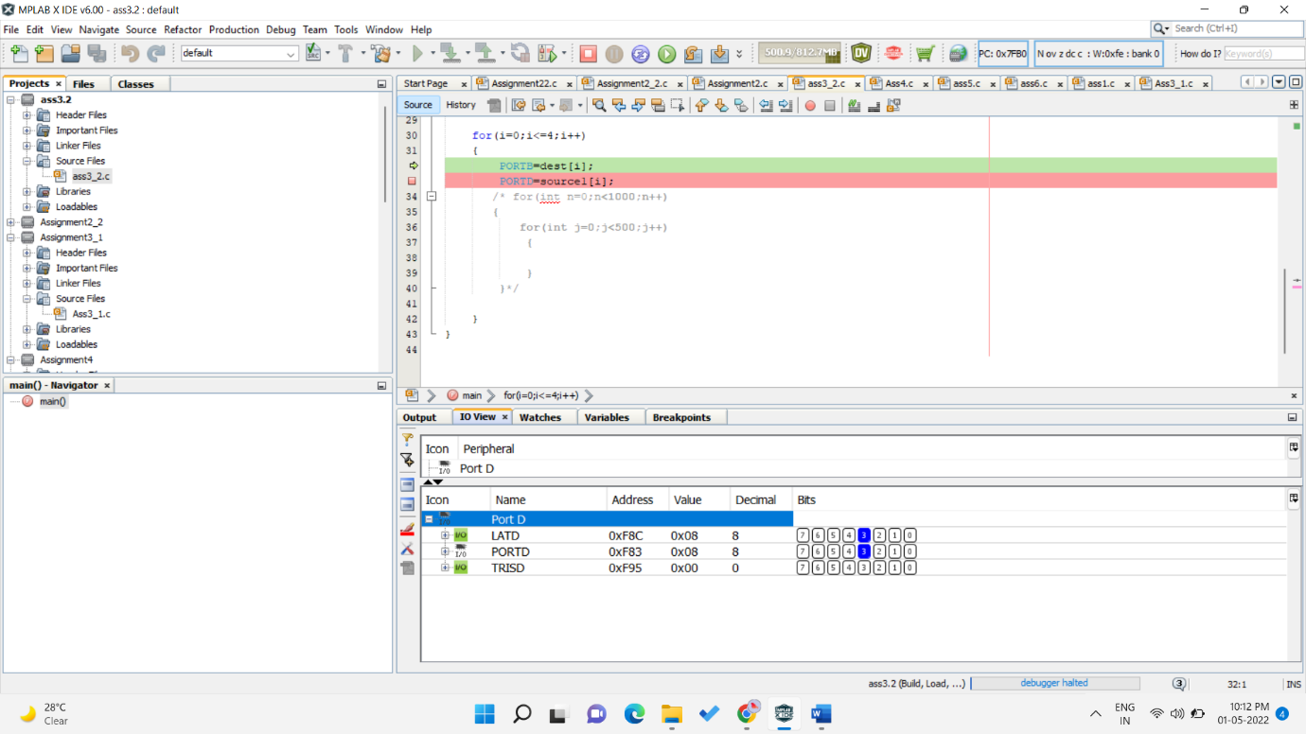

D]09

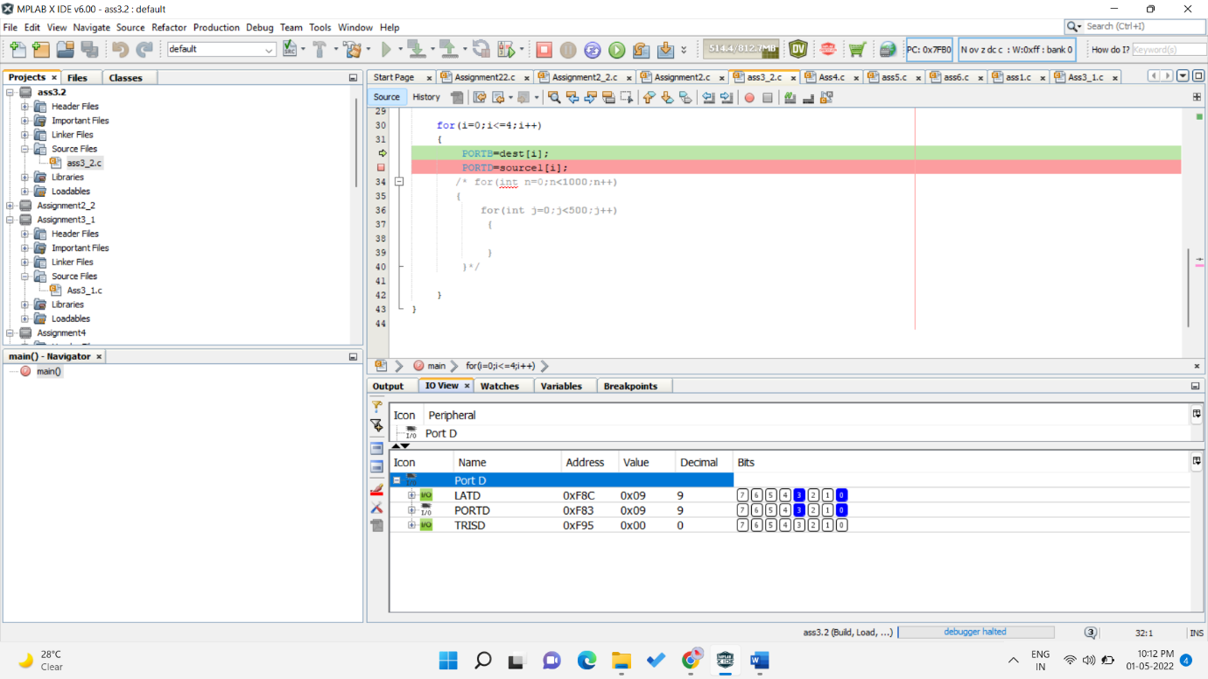

E]10

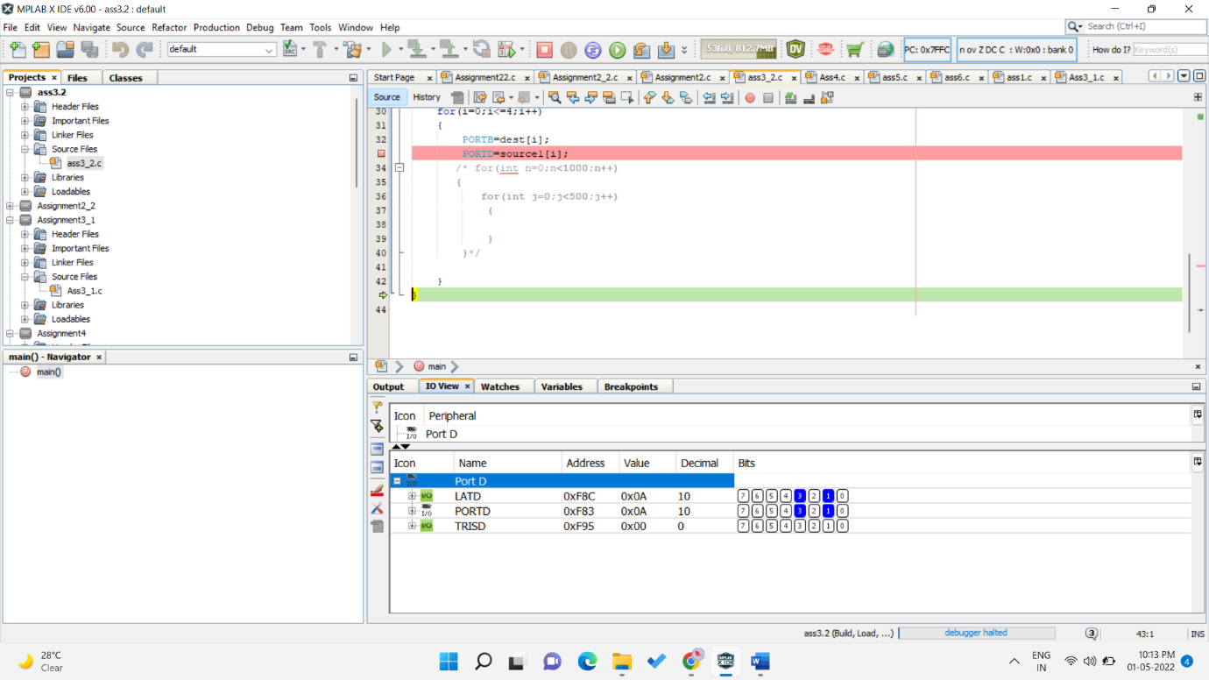

PORT B

A]01

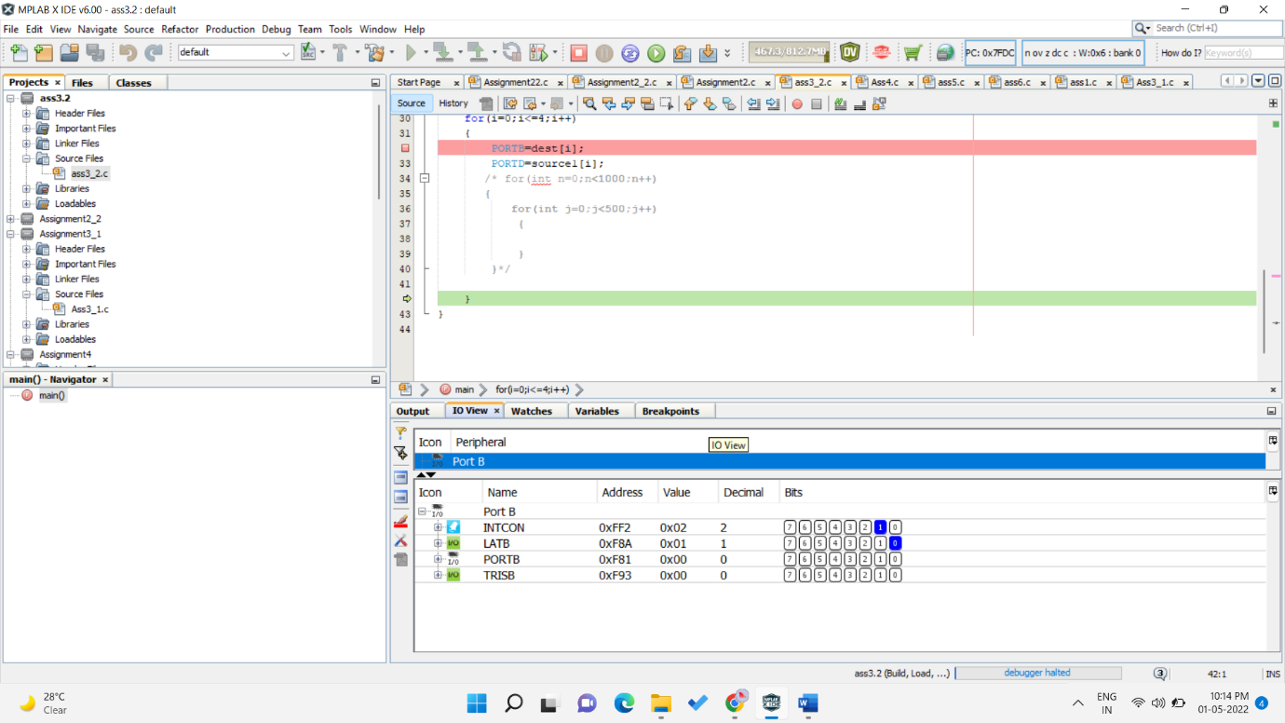

B]02

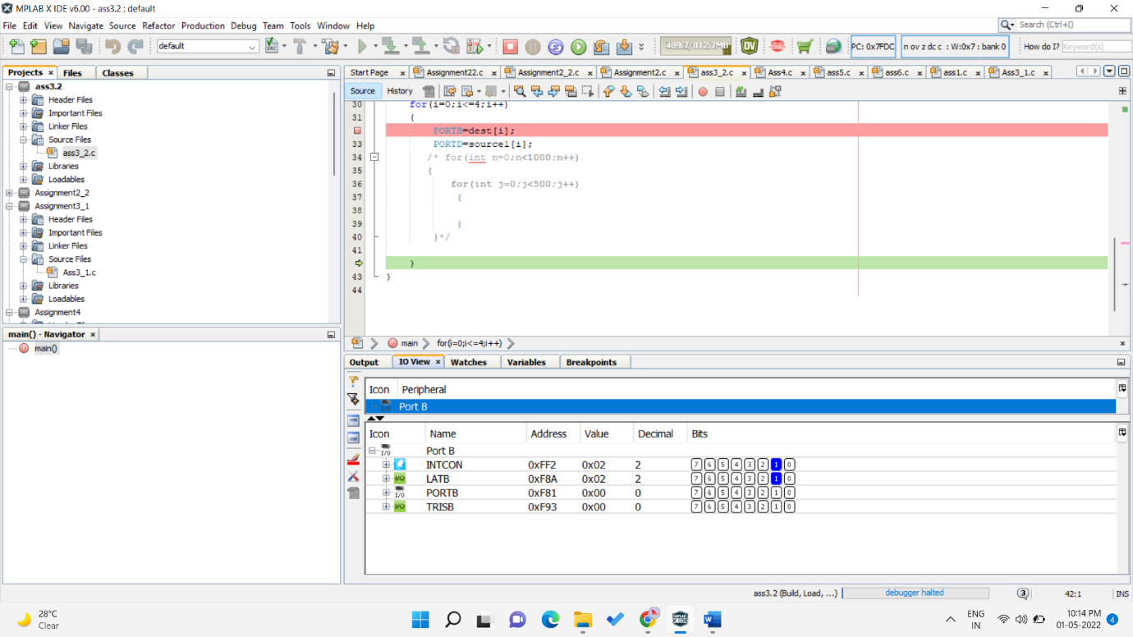

C]03

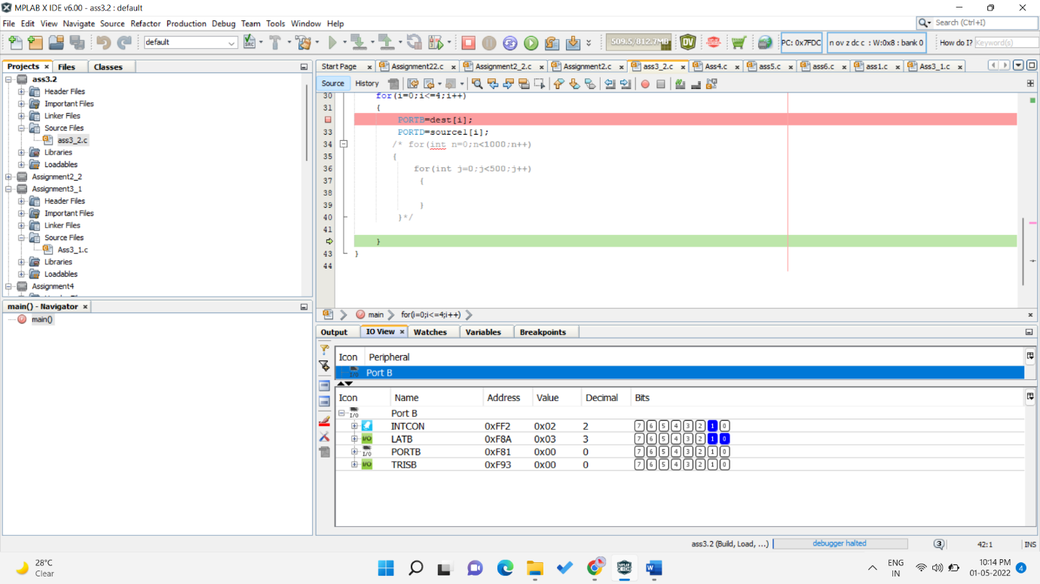

D]04

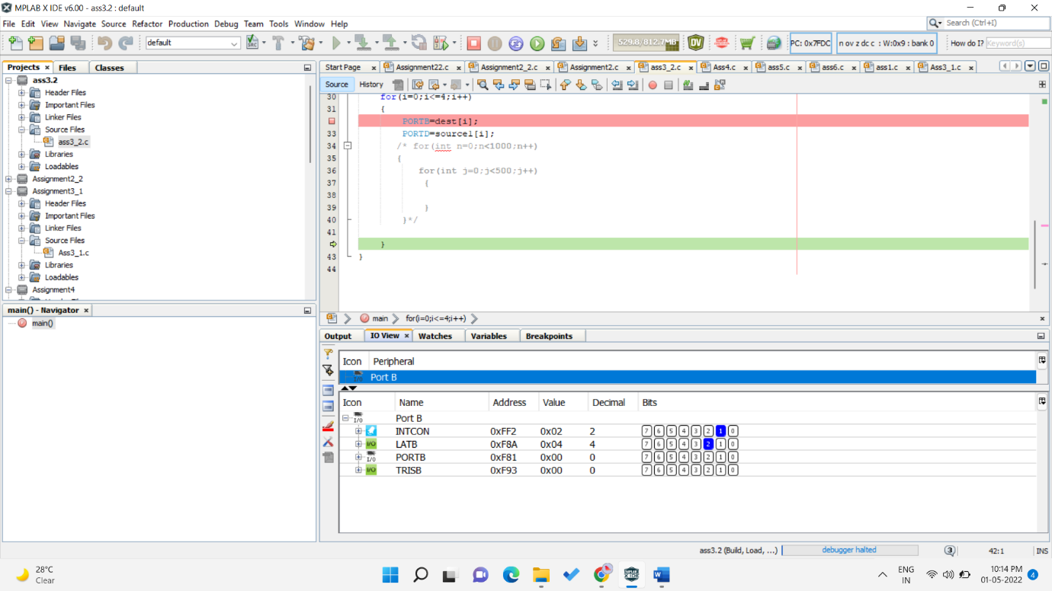

E]05

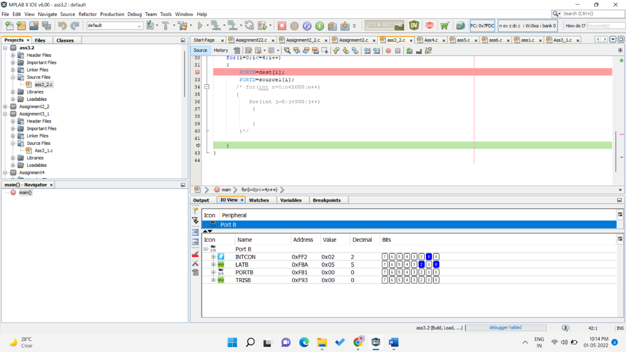

1. PICSIM LAB OUTPUT

A]PORT D=06 ,PORTB=00

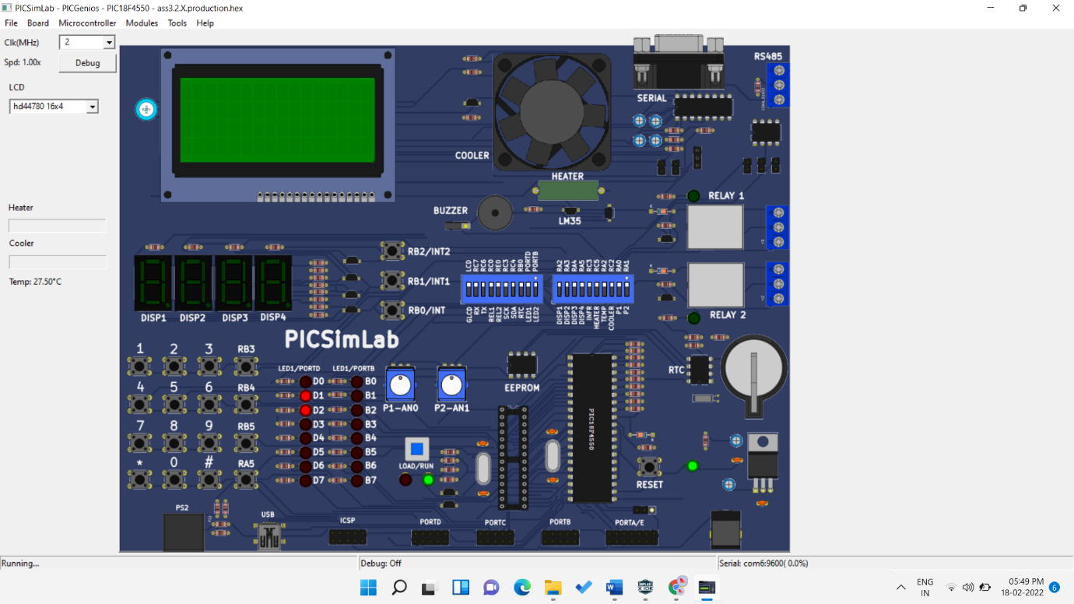

B] PORT D=07 ,PORTB=01

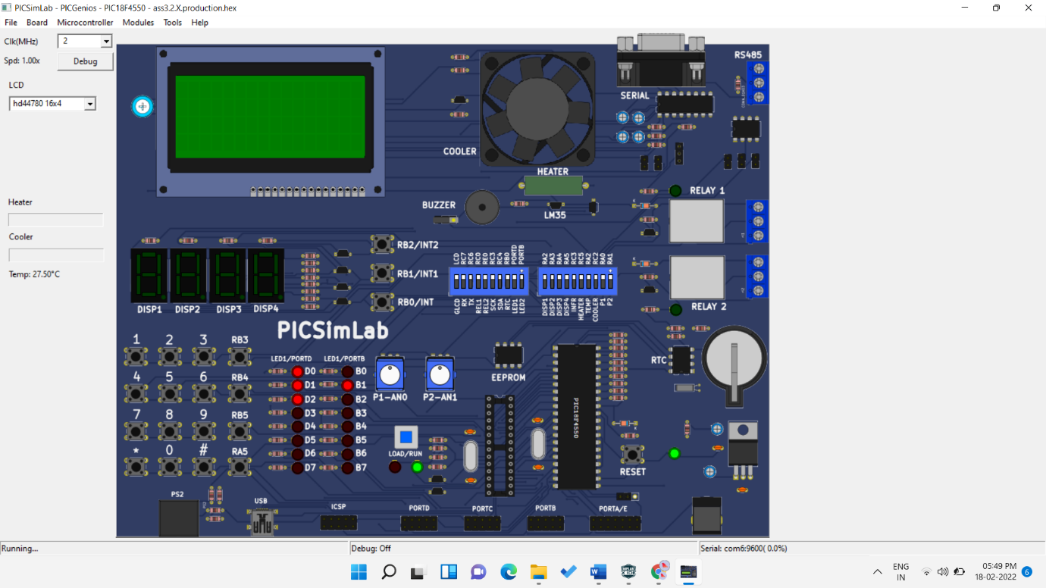

C] PORT D=08,PORTB=02

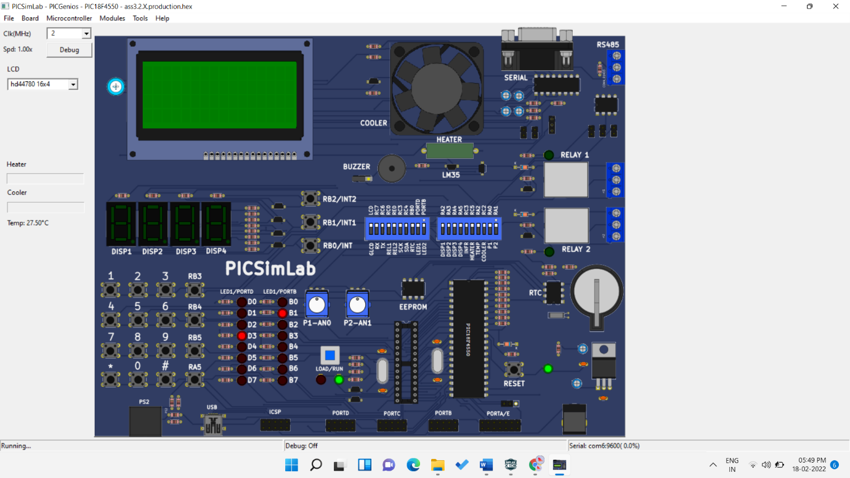

D] PORT D=09,PORTB=03

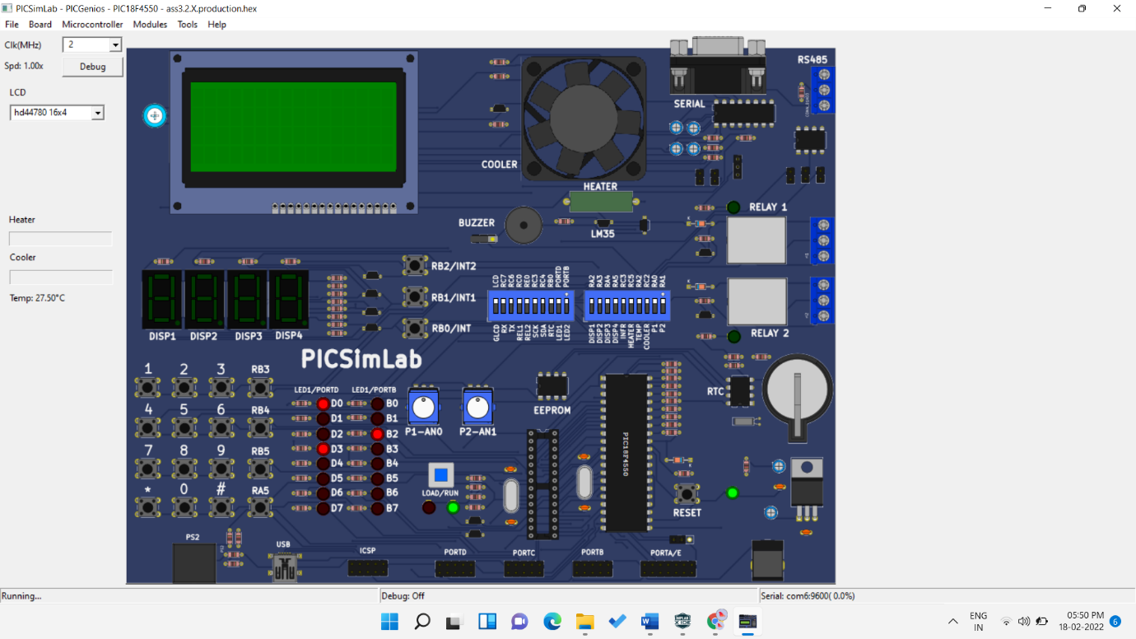

E] PORT D=10,PORTB=04

